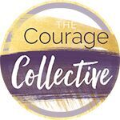
Liability and Photo Release Form

I, ________________________________, hereby certify that I am participating voluntarily in this event. I release [YOUR NAME HERE] and The Courage Collective International or any associated parties from any liability connected to my participation at this event.

I understand that this event may be photographed, recorded, and/or videotaped, and grant my permission for use of any photos, videos, or audio recordings for future promotional media, testimonials and website graphics.

________________________________________ ___________________
Signature Date

Print Name: _________________________________________________________

